ASSIGNMENT - 1

Q. create the following tables with given stuctures and insert sample data as specified:-

A) SALESPEOPLE
Snum int(4)
Sname vacchar(10)
City varchar(10)
Comm float(3,2)

Ans.
->Create table SALESPEOPLE
(Snum int(4),Sname varchar(10),City varchar(10),Comm float(3,2);

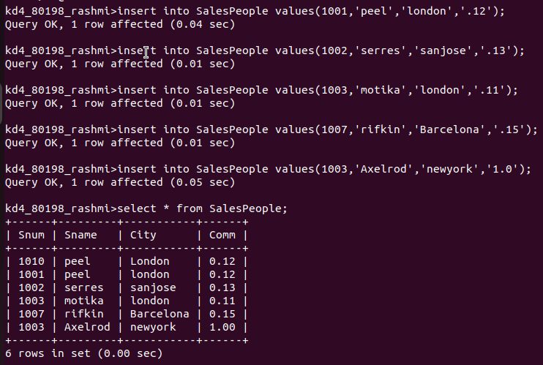

B) Customers
Cnum int(4)
Cname varchar(10)
City varchar(10)
Rating int(4)
Snum int(4)
Ans.
-> create table CUSTOMERS(Cnum int(4),Cname varchar(10),City varchar(10),Rating int(4),Snum int(4) );

-> insert into CUSTOMERS(Cnum,Cname,City,Rating,Snum) values(2001,'Hoffman','London',100,1001),(2002,'Giovanni','Rome',200,1003),(2003,'Liu','San Jose',200,1002),(2004,'Grass','Berlin',300,1002),(2006,'Clemens','London',100,1001),(2008,'Cisneros','san Jose',300,1007),(2007,'Pereira','Rome',100,1004);

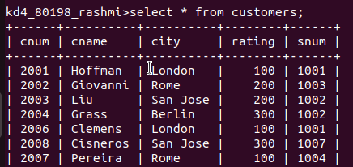

C) ORDERS
Onum int(4)
Amt float(7,2)
Odate date
Cnum int(4)
Snum int(4)

Ans.
-> Create table ORDERS (Onum int(4),Amt float(7,2),Odate date,Cnum int(4),Snum int(4) );
-> Insert into ORDERS
values
-> (3001, 18.69,'1990-10-03', 2008, 1007),
-> (3003, 767.19,'1990-10-03', 2001, 1001),
-> (3002, 1900.19,'1990-10-03', 2007, 1004),
-> (3005, 5160.45,'1990-10-03', 2003, 1002),
-> (3006, 1098.16,'1990-10-03', 2008, 1007),
-> (3009, 1713.23,'1990-10-04', 2002, 1003),
-> (3007, 75.75,'1990-10-04', 2004, 1002),
-> (3008, 4723.00,'1990-10-05', 2006, 1001),
-> (3010, 1309.95,'1990-10-06', 2004, 1002),
-> (3011, 9891.88,'1990-10-06', 2006, 1001);

